PPR: 25th EuroBLECH 2018 - October 2018

AMADA at EuroBLECH 2018

AMADA exhibiting at EuroBLECH: Pushing the limits in speed, energy efficiency and quality · Complete solutions for sheet metal processing · Next generation of IoT concept “V-factory” with machine monitoring and direct-response service possibilities · Theme: “PROCESSING INNOVATION WITH NEW TECHNOLOGIES”.
Haan, 23. October 2018 - AMADA presents the latest highlights from the world of sheet metal processing with a special focus on laser technologies and production benefits delivered by IoT. The Japanese manufacturer will show unique machine technologies with live demonstrations throughout the event. Improved models and expanded ranges will be shown at the exhibition.
The first focus point of this year’s event will be the recent developments in AMADA’s proven ENSIS laser technology powered by in-house developed fiber oscillators. ENSIS technology uses variable beam control to provide high speed and high quality for the processing of flat sheet and tube and even for welding. New machine and automation options will be presented, which provide stable material supply, part sorting and storage.
The second focus point will be the next generation of AMADA’s comprehensive and network-based machine surveillance concept with two new features, allowing monitoring – anytime, anywhere. My V-factory visualizes the whole connected production environment at a glance. The optional new IoT-Support is the second element providing a direct-response customer service concept for error prevention and immediate support.
AMADA will also exhibit its broad range of other technologies, such as the combination of fiber laser cutting and punching, as well as bending. These solutions allow customers to process all types of manufacturing jobs and manage huge varieties of different lot sizes in the shortest time with the highest quality.

Details about AMADA in EuroBLECH:
Hall 12
Booth D06/ F06
23rd to 26th of October 2018 in Hanover, Germany

Press release 1

AMADA VENTIS-3015AJ 4kW
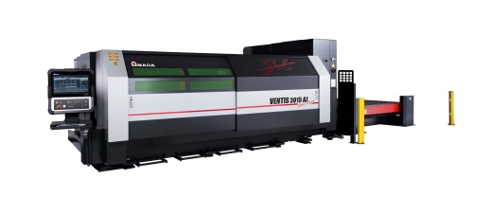
Uncompromising Stainless Steel and Aluminum Cutting with the Fiber Laser

The first cutting laser worldwide of a new fiber laser generation with 4 kW laser power and only one laser module offers the possibility of cutting sophisticated materials without compromise. For the first time, stainless steel, aluminum and other materials can be processed with a cutting quality equal to that of a CO² Laser. The use of an innovative process means that the system is able to oscillate the laser beam in the kerf based on predefined patterns. This not only results in a significantly increased cutting speed, it also guarantees an absolutely precise bevel free cut, for example when processing mild steel by oxygen. The surface roughness achieved in the fiber laser field is unequaled and is only comparable to the quality of a CO² laser. At the same time, the fiber laser burr which is otherwise usual can be almost completely excluded.

Press release 2

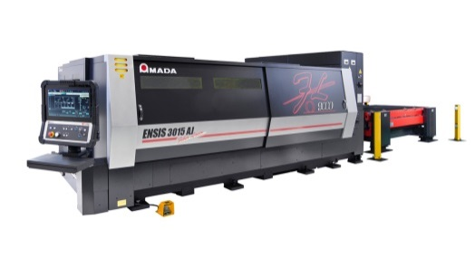
AMADA ENSIS-3015AJ 9 kW fiber laser cutting machine:
Superior processing stability, especially for thick mild steel

Building on the success of the ENSIS machines, AMADA introduces the ENSIS 9 kW, equipped with both the Variable Beam Control technology as ENSIS Technology with new Auto Collimation Mechanism. The combination of these two technologies with single lens capabilities lead to high quality, high speed cutting and high speed piercing, particularly when processing thicker mild steel. For example, 25 mm mild steel can be pierced in one second. Also being demonstrated will be AMADA’s CFC cutting technology to increase cutting speed and reduce assist gas consumption significantly. This machine is also equipped with AMADA’s new electric LST-3015e pallet changer.

Press release 3
AMADA ENSIS-3015AJ 6 kW fiber laser cutting machine:
Fully automated load/unload system with part removal

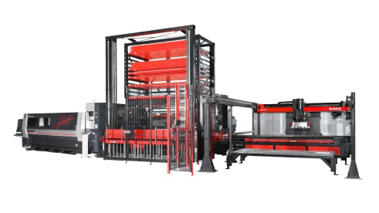
As well as exhibiting an ENSIS 9 kW fiber laser, AMADA also introduces a 6 kW variant at EuroBLECH 2018. As with all AMADA fiber lasers, the ENSIS 6 kW utilizes AMADA’s in-house developed and built fiber laser oscillator. Combining the Variable Beam Control technology and new Auto Collimation mechanism, the evolved ENSIS Technology 6 kW is perfect for high productivity automated applications. Automatic part removal is simplified due to the wide kerf created by these advanced ENSIS technologies when cutting, unlike standard fiber lasers. The ENSIS 6 kW is connected to the ASF-3015EU load/unload tower and the TK-3015L part removal system.

Press release 4
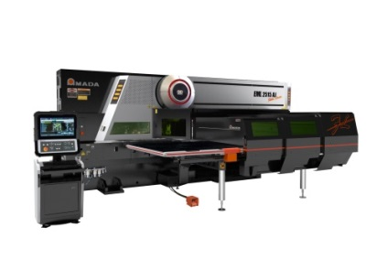
AMADA EML-2515AJ 3 kW punch and fiber laser cutting
combination machine:
Process expansion, reduced running costs and reduced set-up
EuroBLECH 2018 will be the world premiere of the EML-2515AJ servo-electric punch and fiber laser cutting combination machine.. Continuing AMADA’s expansion of its fiber laser combination range, the EML-2515AJ is equipped with AMADA’s own 3 kW fiber laser oscillator and powerful 300 kN punching capacity. Special features round a highly productive machine of the newest generation: Firstly, there is the PDC (Punch and Die Changer) unit that can hold a full 220 punch tools and 440 dies, allowing an automatic tool changing in-cycle to reduce set-up and down times. Secondly, there is the 4 station automatic nozzle changer. The MPT (Multi-Purpose Turret) also contains a 4 station tapping unit. The EML-2515AJ is also equipped with an RMP-3015N automatic load/unload system.

Press release 5
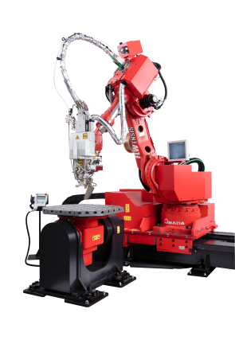
AMADA FLW-ENSIS3000 M5 fiber laser welding system:
Expansion of the welding area with AMADA ENSIS technology
The FLW takes laser welding to a higher level of quality with a reduction of the total lead time. In addition our new solution is equipped with an ENSIS 3 kW fiber laser oscillator which covers many different welding applications through the Variable Beam Control system. The machine features a filler wire function, which is used to ensure high quality, long welding applications and the beam weaving system which allows larger gap welding to be achieved. The M5 model features two separate set- up tables, so the next part can be prepared during the welding cycle.

Press release 6
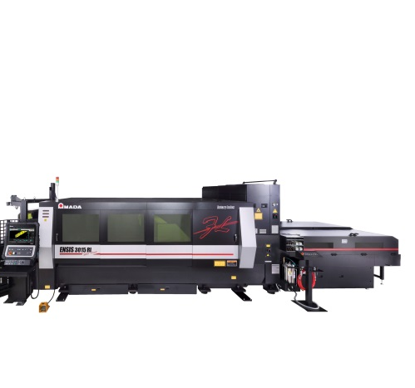
AMADA ENSIS-3015RI 3 kW fiber laser cutting machine:
Productivity expansion for flat sheet and tube processing

Combining AMADA’s ENSIS 3 kW flatbed laser cutting technology with the Rotary Index (RI) tube and profile cutting system, AMADA is exhibiting a machine with very wide range applications. ENSIS technology, with Variable Beam Control, allows for high speed thin material processing and stable thick mild steel cutting. The ENSIS RI has been upgraded to incorporate dual synchronous drive chucks and high speed Z-axis control which reduce run times significantly and ensure high productivity. Round, square and rectangular tubes can all be processed, as well as channel and angle sections. Flat sheet to tube changeover is done in less than 2 minutes. The ENSIS RI is equipped with a dual cutting pallet system which does not need to be compromised when tube processing.

Press release 7
AMADA HFE3i-1003L Press Brake:
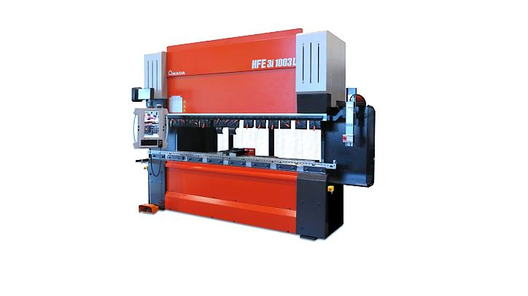
Complete range to cover all bending needs, a perfect mix of safety and flexibility
Based on the solid foundation of the HFE series, AMADA’s HFE3i press brake offers advanced and innovative functions, in addition to a complete range of sizes. As a result, HFE3i is proposed as a flexible and complete range able to cover all bending needs and to satisfy the modern requirement of sheet metal processing. HFE3i-1003L with the next generation of safety device (AKAS 5), long stroke function, equipped with the latest gauging solutions (FAST and U-Shape finger) and with the unique AMADA tool and clamp system (AFH and pneumatic clamp) will be exhibited as effective examples of the HFE3i potential.

Press release 8
AMADA HG-2204ATC Press Brake with automatic tool changer:
The unique solution to win competitiveness in the era of lot
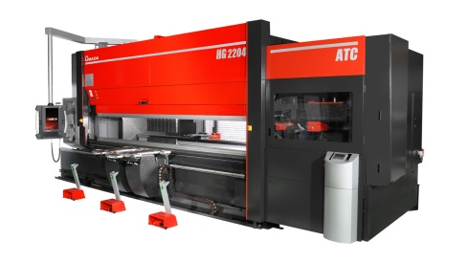
size and lead time challenges
Competitiveness in the era of complex challenge, from the reduction of the batch sizes, to the short lead time and the high quality requirement, is key point of modern business; HG-ATC series is the answer to each modern requirement offering invaluable benefit in the bending process to customer. HG-2204ATC, the formidable and well known AMADA ATC, equipped with the ergonomic SF75 sheet follower and the latest gauging solution (U-Shape finger) will be exhibited; in addition AMADA will present a new function for the active angle measurement on 3 points which assures the highest precision in terms of angle and linearity.

Press release 9
AMADA EG-4010 bending machine:
The state-of-the-art EG-4010 revolutionizes the press brake
concept into a high productivity, ergonomic workstation.

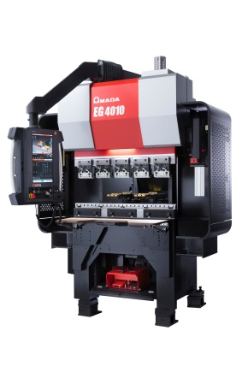
The new bending machine EG-4010 completes the AMADA portfolio as the first ergonomic servo-electric press brake with the unique AMADA DSP system and sets standards in speed, comfort, reduced electrical consumption and intuitive programming. With 40t and 1050 mm table length, it works perfectly for the production of small and precise parts. Furthermore, AMADA's Bi-J mechanical angle measurement system provides the highest quality on any material and thickness. In response to the risen demand for ergonomic machines, the EG-4010 comes with an ergonomic operator chair, front table, pendant arm and foot rest - all adjustable for highest operator comfort.

Press release 10
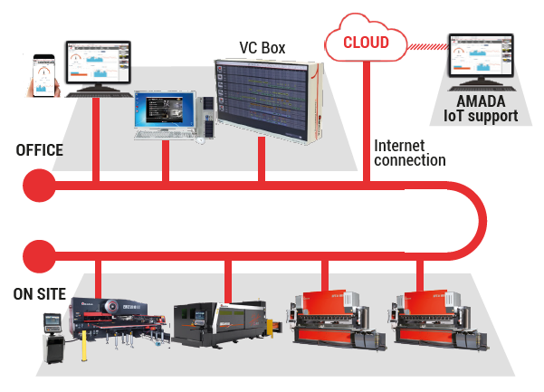
AMADA Digital solution:
IoT concept V-factory with machine monitoring and direct-response service possibilities
The next generation of AMADA’s comprehensive and network-based machine surveillance concept will be shown with two new features, allowing monitoring – anytime, anywhere. My V-factory visualizes the whole connected production environment at a glance. The optional new IoT-Support is the second element providing a direct-response customer service concept for error prevention and immediate support.

Please provide evidence copy in the event of reproduction.

Press release 1
AMADA VENTIS-3015AJ 4kW
Uncompromising Stainless Steel and Aluminum Cutting with the next generation of Fiber Laser
The first cutting laser worldwide of a new fiber laser generation with 4 kW laser power and only one laser module offers the possibility of cutting sophisticated materials without compromise. For the first time, stainless steel, aluminum and other materials can be processed with a cutting quality equal to that of a CO₂ Laser.

Cutting performance in a new dimension
AMADA is introducing a new fiber laser cutting system with the VENTIS-3015AJ 4kW which can overcome the current limitations of fiber laser technology using a revolutionary flexible beam guiding system. With only 4 kW laser power, the system is able to perform to a level that is usually only achieved by 6 or 8 kW systems. The use of an innovative process means that the system is able to oscillate the laser beam in the kerf based on predefined patterns. This not only results in a significantly increased cutting speed, it also guarantees an absolutely precise bevel free cut. The surface roughness achieved in the fiber laser field is unequaled and is only comparable to the quality of a CO₂ laser. At the same time, the so called fiber laser burr which is otherwise usual can be almost completely excluded.

Cuts through all materials – always with the highest possible beam quality
Flawless and consistent quality is a particularly decisive factor for demanding clients. AMADA VENTIS-3015AJ is the solution for this task due to a continuously maintained laser mode. As a result, the AMADA VENTIS-3015AJ achieves unusually high-quality results for a 4kW fiber laser. The beam parameter product (BPP) is maintained consistently at BPP ≤ 0,9 mm*mrad. Due to the diverse oscillating patterns of the laser beam, each task can be approached individually; thin as well as thick metal sheets can be cut at its individual maximum speed and with equally high-quality precision.

Additional cost savings as a secondary effect
In addition to its high capacity for performance, AMADA VENTIS-3015AJ also offers a high level of resource sustainability. The significantly higher processing speed provides an additional saving in costs for each manufactured part, because the required power and cutting gas can be further reduced to a significant extent.

Technical data VENTIS-3015AJ
Laser | Own-developed fiber laser source with flexible beam pattern
Laserpower | 4000 W
Work range | 3000 x 1500 mm
Max. feed rate  (X-Y simultaneous) | 170 m/min
Special feature | The laser beam oscillates in the kerf based on flexible patterns.

Image material

The VENTIS-3015AJ stands for
perfect cutting results in
stainless steel, aluminum and
many other materials.
Source: AMADA GmbH

Further information:
AMADA GmbH
Amada Allee 1
42781 Haan - Germany
www.amada.de
Press contact: Axel Willuhn
Telefon: +49 2104 2126-0
E-Mail: axel.willuhn@amada.de

Please provide evidence copy in the event of reproduction.

Press release 2&3

New Fiber Laser Cutting Machines AMADA ENSIS-3015AJ with 6 and 9 kW

Exceptionally flexible productivity due to ENSIS technology, now available in 6 and 9 kW

Effective from now on, the exceptionally successful ENSIS series is also available in the higher range performance spectrum. In addition to the well-established ENSIS Variable Beam Control, an Auto Collimation Mechanism is used here as well

The Variable Beam Control is currently already a success with respect to flexibility in laser cutting applications, and the introduction of the additional Auto Collimation Mechanism expands the spectrum of possible applications even further. By adjusting the beam shape and through the additional options for influencing the beam diameter and focal position, almost any material, regardless of thickness, can be cut under optimal conditions. Piercing times are reduced drastically – 25 mm regular steel can be precisely pierced in approximately one second.

Focus on high-level availability and around-the-clock production
The use of new ENSIS fiber laser cutting machines in the higher level performance category increases productivity above all in the processing of medium to thick materials. Special benefits are noted here in particular by using nitrogen as a cutting medium.
By using the optimally adapted automation solutions including the component sorting options, the new ENSIS fiber laser cutting machines, for example, in case of multiple machine operation. Other work can also be done concentrated without time pressure, while ENSIS continues to work reliably. Everything that does not bind the operator to the machine shortens the time for the so-called "Return of Invest".

Creating safe automatic production processes with ENSIS-3015AJ
The kerf for the take out process can also be adjusted to allow the parts to be taken out quickly and safely. This is even more important for the automatic part take out process, and was in the past an almost insurmountable hurdle for conventional laser machines.At EuroBLECH the 6 kW version of the AMADA ENSIS-3015AJ is equipped with an ASF-EU loading and unloading tower. The tower increases the material capacity for raw material and cut sheets and is perfectly coordinated by the processes with the performance of the ENSIS. The individual sorting function TK-L

can sort and store the cut parts, which subsequently prevents any mix-up of parts as well as simplifying their accurate assignment.

Technical data ENSIS-3015AJ
Laser | Own-developed fiber laser source with Variable Beam Control and Auto Collimation Mechanism
Laserpower | 6000 und 9000 W
Work range | 3000 x 1500 mm
Max. feed rate  (X-Y simultaneous) | 170 m/min
Special feature | ASF-EU Loading and unloading unit and TK-L part sorting unit (with 6kW)

Image material
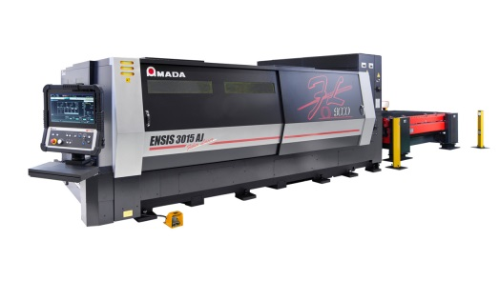
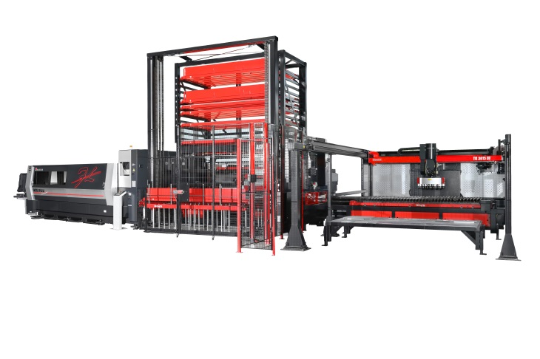The ENSIS-3015AJ stands for exceptional productivity and a process-safe automation
Source: AMADA GmbH

Further information:
AMADA GmbH
Amada Allee 1
42781 Haan - Germany
www.amada.de
Press contact: Axel Willuhn
Telefon: +49 2104 2126-0
E-Mail: axel.willuhn@amada.de

Please provide evidence copy in the event of reproduction.

Press release 4

New Punch and Fiber Laser cutting Combination Machine AMADA EML-2515AJ with 3 kW and PDC Tool Changer System
Integrated Production Solution of the Highest Standard

With the introduction of the EML-2515AJ, AMADA is expanding its portfolio with the addition of an especially powerful punch and fiber laser cutting combination machine equipped with an energy-efficient, servo-electric drive. Featuring an AMADA 3 kW fiber laser, it has the considerable punching capacity of 300 kN in large format and numerous integrated production processes for production around the clock.

Punching and forming, as well as thread-cutting and forming can be achieved quickly and precisely with this new high-performance combination machine. Even complicated tasks can be now implemented faster and more precisely than before – up to 20% faster punching speed and up to 150% increased cutting speed than the previous model result in a level of productivity that sets new standards in the punch and fiber laser combination segment. With its space-saving, integrated safety cabin to prevent reflection and flying sparks, the AMADA EML-2515AJ can be set-up in even tight space.

Integrated processes make subsequent rework unnecessary
Due to its numerous useful features, the new AMADA EML-2515AJ enables an almost uninterrupted production process. The Z-Turret with 44 stations can be upgraded with up to 220 punches and 440 dies by means of an automatic tool changer system. The maximum tool diameter is 114.3 mm. An integrated nozzle changer and a one-lens strategy mean that manual set-up processes are not required.
The low-maintenance 3 kW fiber laser and automatic cutting plate cleaning, together with numerous other equipment features, are the foundation for profitable nonstop production.

AMNC-3i control system and compact automation
At EuroBLECH, the AMADA EML-2515AJ can now also be seen featuring the AMADA AMNC-3i control system. A compact loading and unloading unit, the RMP-3015N, takes care of material handling. In addition, the AMADA EML-2515AJ can also be upgraded with numerous additional automation modules.

Technical data EML-2515AJ mit PDC
Technology | Punch-fiber-laser-combination
Laserpower | 3000 W
Punching force | 300 kN
Max. feed rate  (X-Y_{L} simultaneous) | 140 m/min
Special feature | PDC tool changer, RMP-3015N loading and unloading unit

Image material
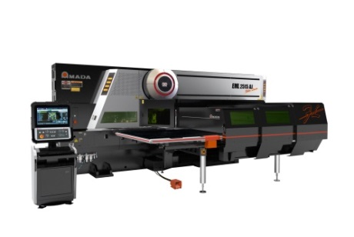 | The EML-2515AJ with PDC tool changer and RMP-3015N stands for maximum, uninterrupted productivity..  (PDC and RMP-3015N not depicted on the image)

Source: AMADA GmbH
Further information:
AMADA GmbH
Amada Allee 1
42781 Haan - Germany
www.amada.de
Press contact: Axel Willuhn
Telefon: +49 2104 2126-0
E-Mail: axel.willuhn@amada.de

Please provide evidence copy in the event of reproduction.

Press release 5
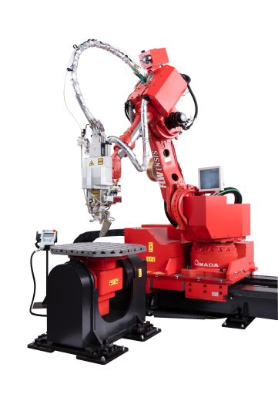
The Next Generation of the AMADA FLW-ENSIS3000 M5 Fiber Laser Welding Cell
Variable Beam Control for Welding without
Subsequent Rework

With the interplay between the FLW welding cell and the ENSIS technology, AMADA takes laser welding to a new level of quality and significantly reduces processing times. The ENSIS 3 kW fiber laser and the Variable Beam Control system give an impressive performance with a diverse range of welding tasks. The welding wire supply ensures consistent welding seams and the weaving process effortlessly bridges larger gap clearances. The model demonstrated at EuroBLECH features an M5 shuttle table system which reduces cycle times significantly.

The FLW-ENSIS laser welding cell, as the latest development in the FLW series from AMADA, is able to process significantly higher gaps than is normally possible in laser welding technology. This is based on the well-established 3 kW fiber laser with Variable Beam Control and the innovative weaving technology in which the integrated, rotating optical device allow the laser beam to oscillate. This process has been further optimized in the FLW-ENSIS with the “ring mode beam”. Here the laser beam is distributed in a circle and, together with the weaving technology and the push-pull wire guiding, it achieves optimal bridging of even larger gaps.

Prevents residue, deformation and discoloration
The FLW-ENSIS3000 M5 laser welding cell enables precise welding of even thin-walled metal sheets and leaves practically no residue, deformation or discoloration on the rear side. This outstanding quality feature is the result of the fiber laser’s precisely defined power input since its intensity and range can be precisely regulated during the welding process, always individually and precisely adapted to the material of the component being subjected to processing.

Welding in record time
The well-established ENSIS technology, with the oscillator developed in-house by AMADA, enables particularly high performance that leaves conventional welding systems far behind. The FLW-ENSIS effectively merges a diverse range of materials in up to 50% of the normal time. The FLW-ENSIS3000 M5 also requires only a fraction of the normal time for overlapping welding tasks, whereby the welded area is extremely resilient.

In addition, FLW-ENSIS performance is equally secure during butt welding, as well as welding with wire input, whereby it even features a variance option to weld with or without wire. Last but not least, a shuttle table system is now available for Version M5, which significantly decreases cycles times and respectively down times.

Technical data FLW-3000ENSIS M5
Laser | Own-developed fiber laser source with Variable Beam Control
Laserpower | 3000 W
Robot | 6-axis robot
Robot linear axis | 4000 mm
Special feature | Two twist and tilt tables, as shuttle table system
Safety feature | Safety cabin corresponding to T2 safety category for man-less operation

Image material
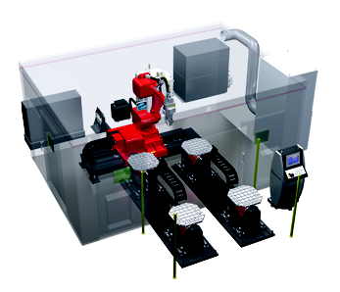 | The FLW-3000ENSIS M5 welding cell is also suitable for bridging larger gaps.
Source: AMADA GmbH
Further information:
AMADA GmbH
Amada Allee 1
42781 Haan - Germany
www.amada.de
Press contact: Axel Willuhn
Telefon: +49 2104 2126-0
E-Mail: axel.willuhn@amada.de

Please provide evidence copy in the event of reproduction.

Press release 6
The new fiber laser cutting machine AMADA ENSIS-3015RI with 3 kW
All-in-one solution for sheet-metal, pipes and profiles
The Rotary Index (RI) unit with integrated materials measurement meets a high-performance 3 kW laser cutting system with ENSIS laser resonator. Converts in seconds from flatbed laser to pipe and profile processing – set-up becomes a minor issue.

With the ENSIS-3015RI in 3 kW, AMADA introduces a new laser cutting system based on the well-established ENSIS series whose strength lies in own developed beam sources and the unique Variable Beam Control for ultimate flexibility and productivity. Expanding on the AMADA FO-3015M2 RI CO₂ laser system, it provides all the advantages of fiber laser processing in terms of speed, profitability and cutting quality. With its AMADA original Variable Beam Control function, the ENSIS-3015RI 3 kW has the flexibility to be able to process all imaginable types and thicknesses of material, regardless of whether the material in question is stainless steel or a non-ferrous material such as aluminum, copper, brass, or titanium. The most current generation of pipe axis units (RI) has been developed and perfectly adapted for use in the ENSIS-3015RI 3 kW. This means a further significant increase in speed and accuracy, whereby the optimized pipe guidance ensures almost scratch-free processing.

Switching between flatbed, pipe and profile processing in no time at all
The additionally integrated measurement sensor “Touch-Probe” enables the quick and precise reference measurement of the component. The automatic nozzle changer, as well as the option to cut all materials and material thicknesses with a single cutting lens, reduces potential waiting and downtime significantly. Separated pipes and profiles are safely caught in a special tub. The lateral sliding doors ensure optimal access and provide reliable protection against reflection and sparks.

Networked for even more performance
The AMADA ENSIS-3015RI, featuring the latest AMNC 3i control system and network option, can be seen live at EuroBLECH. This innovative control system guarantees easy and intuitive operation, contributes to set-up time minimization and provides a reliable analysis of machine data.

Technical data ENSIS-3015RI
Laser | Own-developed fiber laser source with Variable Beam Control
Laserpower | 3000W
Work range | 3000 x 1500 mm
Max. feed rate  (X-Y simultaneous) | 170 m/min
Special feature | Rotary Index for sheet -, tube and profile cutting

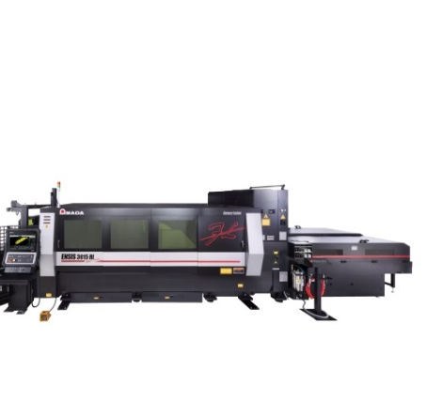
Image material
Source: AMADA GmbH

The ENSIS-3015RI is an All-In-One machine
for sheet -, tube - and profile cutting

Further information:
AMADA GmbH
Amada Allee 1
42781 Haan - Germany
www.amada.de
Press contact: Axel Willuhn
Telefon: +49 2104 2126-0
E-Mail: axel.willuhn@amada.de

Please provide evidence copy in the event of reproduction.

Press release 7

AMADA HFE3i-1003L Press Brake:
All-Round Solution for Safety and Maximum Flexibility

Based on the solid foundation of the HFE series, the network-compatible press brake HFE3i-1003L provides an all-round solution for almost all bending tasks.

The HFE series offers a broad-based processing spectrum of
500 kN to 4,000 kN, as well as bending lengths from 1,250 to 6,000 mm, enabling almost any bending task to be performed. With its high-level flexibility and long stroke of 350 mm, the HFE3i-1003L is capable of processing a diverse range of material thicknesses as well as special component geometries.

State-of-the-art safety systems and back gauge solutions
The next generation of the well-established AKAS 5 provides the highest possible level of safety and convenience for operators. The HFE3i-1003L features the most current back gauge solution FAST Finger, which enables high-performance processing speed in the safety zone.

The pneumatic clamping system R-Grip, which minimizes the set-up and work processes, has been integrated for quick installation and removal of the AMADA-AFH tools.

The latest generation in controls
The HFE3i-1003L includes a network-compatible, user-friendly and intuitive control system (AMNC 3i) which allows bending tasks to be performed in a fast and straightforward manner. The 18.5" multi-touch screen features four different programming options (teach mode, direct mode, 2D and 3D mode) for a high-level of flexibility and productivity.

Extensive upgrading options
Numerous options complete the configuration of the HFE3i-1003L. The Delta-X back gauge enables independent operation of the stop fingers in a process area of +/- 150 mm in X-direction and is equipped with 2 powered fingers. The AMADA angle measurement systems BI-S or BI-M provide the utmost accuracy and mean that test bending with material waste can be excluded altogether. The bending aid SF-75 assists the operator with bulky and heavy components that are difficult to move.

Technical data HFE3i-1003L
Press capacity | 1000 kN
Beam length | 3110 mm
Stroke | 350 mm
Open height | 620 mm
Back gauge | Delta-X, 7-axis

Image material
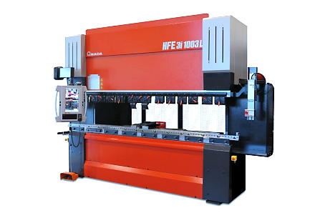 | Based on the solid foundation of the HFE series, the networkable HFE3i-1003L press brake offers an all-round solution for almost all bending tasks.

Source: AMADA GmbH

Further information:
AMADA GmbH
Amada Allee 1
42781 Haan - Germany
www.amada.de
Press contact: Axel Willuhn
Telefon: +49 2104 2126-0
E-Mail: axel.willuhn@amada.de

Please provide evidence copy in the event of reproduction.

Press release 8

AMADA HG-2204ATC Press Brake with Automatic Tool
Exchange System
The appropriate solution for the race with short delivery terms and decreasing lot sizes

As a trailblazer for press brakes with an automatic tool changer, the HG-ATC models are still unsurpassed – in comparison to conventional systems, the set-up time has been reduced drastically. This results in maximum production efficiency, especially for the smallest lot volumes and for complicated components requiring frequent tool exchanges.

The automatic tool changer for maximum flexibility
Upper and lower tools are placed in the tool clamper precisely and quickly. Set-up times are reduced by approximately 70 percent compared to conventional systems. For example, the HG-ATC can set up 32 tools in 36 seconds flat. In contrast to other press brakes, each tool in the HG-ATC can be set up as positive as well as negative in order to accommodate even the most diverse geometries of parts. The HG-ATC can even process bending lengths of 5-10 mm effortlessly, because it also features a particularly small tool separator. As a result, an HG press brake with automatic tool exchange system (ATC) can easily replace two conventional systems requiring manual set-up.

External programming increases equipment utilization
The ultra-modern 3i-control system and external programming option with the VPSS 3i Bend software noticeably decreases task preparation time and increases the productivity of the HG-ATC. Upon loading the desired component, the software will automatically calculate the set-up plan and bending sequence, as well as the required tools. All of the information is stored on the centralized VSDD server and can be recalled at any time.

Latest feature of the HG-2204ATC
The latest generation of the HG-2204ATC, which was presented at the tradeshow, offers special advantages for extra-long bending parts – due to the three-point calibration, the crowning system is actively integrated in the angle measurement. The bending angle of the component is measured on the left, the center and on the right in order to ensure consistent bending results throughout the entire length.

Technical data HG-2204 ATC
Press capacity | 2200 kN
Beam length | 4000 mm
Punch and Die Stocker | 18/25
Max. tool capacity | 34400 mm
Sheet Follower SF 75 | 2-armed with park position
Active Angle Measurement system | Bi-S

Image material
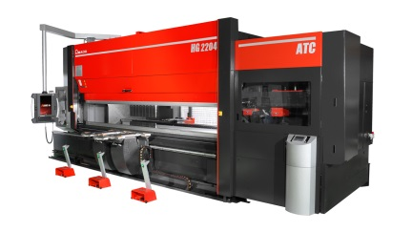 | The HG-2204 ATC with automatic tool changer is a real all-rounder for small batch sizes and frequently changing products.
Source: AMADA GmbH

Further information:
AMADA GmbH
Amada Allee 1
42781 Haan - Germany
www.amada.de
Press contact: Axel Willuhn
Telefon: +49 2104 2126-0
E-Mail: axel.willuhn@amada.de

Please provide evidence copy in the event of reproduction.

Press release 9

AMADA EG-4010 Press Brake

The innovative EG-4010 for maximum productivity and ergonomics

The new press brake EG-4010 completes the AMADA portfolio as the first servo-electric powered, ergonomic press brake with the patented AMADA DSP system and sets standards with regard to speed, convenience, reduced power consumption and intuitive programming.

Low-maintenance electric drive results in high speeds
With the EG-4010, AMADA now introduces a compact press brake featuring low power consumption and high output; high approach and bending speeds guarantee short cycle times. The electric drive ensures low maintenance requirements, because oil changes, for example, are not required. The precisely positioned beams ensure precise repetition (0.001 mm) and the utmost level of quality.

The latest generation in controls
As the latest generation of AMADA equipment, the EG-4010 features a network-compatible, user-friendly and intuitive control system (AMNC 3i) which is able to perform bending tasks in a fast and straightforward manner.

Ergonomic features and durable equipment frame
In response to the high demand for ergonomically designed equipment, the EG-4010 offers numerous such features, such as an adjustable work chair, height-adjustable front table and foot rest, as well as a height-adjustable control panel with left or right side positioning for the utmost operating convenience. Due to its high stability, the newly designed equipment frame of the EG-4010 also accommodates the processing of a diverse range of sheet-metal thicknesses. Its compact construction also enables space-saving placement in small production facilities, thereby increasing productivity.

Optional active angle measurement and Delta-X back gauge
The angle measurement system Bi-J by AMADA, which is positioned between the lower tools, provides the highest possible accuracy for all materials and thicknesses up to 6 mm; this means that test bending with wasted materials is avoided completely. With up to four sensors, even more sophisticated set-up plans can also be implemented.

The Delta-X back gauge enables independent operation of the stop fingers in a process area of +/- 150 mm in X-direction and is equipped with two powered fingers.

Technical data EG-4010
Drive | Dual Servo Drive
Press capacity | 400 kN
Beam length | 1050 mm
Back gauge | Delta-X, 5 Achsen
Ergonomy pack | Adjustable table and chair, 2 drawers
Active Angle Measurement system | Bi-J

Image material
With 400 kN press force and 1050 mm table length, the EG-4010 is perfectly suited for the production of small and complex parts.
Source: AMADA GmbH
Further information:
AMADA GmbH
Amada Allee 1
42781 Haan - Germany
www.amada.de
Press contact: Axel Willuhn
Telefon: +49 2104 2126-0
E-Mail: axel.willuhn@amada.de

Please provide evidence copy in the event of reproduction.

Press release 10

AMADA Digital solution:

Production at a glance - simple, clear, at any time

AMADAS IoT concept with production monitoring and interactive support

With the new holistic concept of the intelligent "V-factory", AMADA focuses on the customer's needs to optimally utilize his production capacity while always maintaining an overview. It is essential not only to observe the factory environment at a glance, but also to be able to react immediately in an emergency. Time is money, as they say.

Background to the development of V-factory
In times of constant change, a producer must truly be able to adapt to many risk factors. Varying lot sizes and growing customer demands in regard to the complexity of components, a shortage of skilled workers and technical experts, as well as the demand for short throughput and delivery times are a real challenge to any entrepreneur. AMADA's V-factory concept offers practical solutions to counter bottlenecks and downtimes in advance.

The foundation of success: Efficient machine monitoring and interactive customer service
V-factory displays the production environment on a single interface. The customer can quickly and easily read the machine status like the running and completed programs. V-factory informs about the exact running and set-up times, differentiating exactly between standby and downtimes. These and many other features, such as for production quantities, thus represent an ideal system for optimally designing productive processes.

The worst case is also taken care of, with a new AMADA service concept that takes effect in the case, when the customer is not aware of machine errors or potential dangers to his production process. As incremental part of V-factory, the AMADA IoT support provides fast and reliable assistance with maintenance issues. Depending on the customer's wishes, the support either switches on automatically in the event of warning messages or otherwise, reacts only after the customer decided to establish the contact by himself. In this way, many service calls can be avoided in advance, while at the same time the customer's data security is guaranteed.

Customer friendliness and usability
V-factory will be available in various booking models, which will also cover the monitoring of non-AMNC machines. In this way, every customer who wants to make his production as innovative as possible can be picked up. Recommended is the use with AMADA AMNC 3i control and the VPSS3i Software Solutions Pack.

Image Material
Source: AMADA GmbH

Further information:
AMADA GmbH
Amada Allee 1
42781 Haan - Germany
www.amada.de
Press contact: Axel Willuhn
Telefon: +49 2104 2126-0
E-Mail: axel.willuhn@amada.de

Please provide evidence copy in the event of reproduction

About AMADA GmbH

The AMADA Group is one of the world's leading manufacturers of sheet metal working machines. AMADA GmbH offers a comprehensive range of cutting, bending, welding, punching and laser technologies. Modular automation components, software applications and a wide range of tools round off this broad portfolio. In addition, AMADA offers its customers a wide range of services. The AMADA Group was founded by Isamu Amada in Japan in 1946. The German subsidiary AMADA GmbH has existed since 1973.

Further information:

 | AMADA GmbH  Amada Allee 1  42781 Haan - Germany  Press Contact:  Axel Willuhn  Phone: +49 2104 2126-0  E-mail: axel.willuhn@amada.de,  www.amada.de |  | AMADA ITALIA S.r.l  Via Amada I., 1/3  29010 Pontenure (Piacenza) - Italy  Press Contact :  Sonia Sirocchi  Phone : +39 (0)523 872111  E-mail: lorella.groppi@amada.it  www.amada.it
 | AMADA UK Ltd  Spennells Valley Road,  Kidderminster  Worcestershire, DY10 1XS - England  Press Contact:  Cathryn Morris  Phone: +44 (0) 1562749500  E-mail:cathryn.morris@amada.co.uk  www.amada.co.uk |  | AMADA Europe  Paris Nord 2  96 avenue de la Pyramide  93290 Tremblay-en-France - France  Press Contact :  Valérie SALAVIN  Phone : +33 (0) 1 49 90 30 00  E-mail: valerie.salavin@amada-eu.fr
AMADA SA
Paris Nord 2
96 avenue de la Pyramide
93290 Tremblay-en-France - France
Press Contact :
Jean Pascal Reyrolle
Phone : +33 (0) 1 49 90 30 00
E-mail: jpreyrolle@amada.fr
www.amada.fr

Please provide evidence copy in the event of reproduction.

